**Annual Report 2015**

**Women with Disabilities Development Foundation (WDDF)**

**House#712/1, Road#10, Adabar, Bytul Aman housing,**

**Mohammadpur, Dhaka-1207**

**Brief Description of the accomplished activities:** We are concluded the following activities, during the period of 01 January to 31 December 2015 are as follows:

1. **National Executive Council Meeting: Seven National Executive Council (NEC) meetings were held during this reporting year (From 01 January to 31 December2015).**
2. 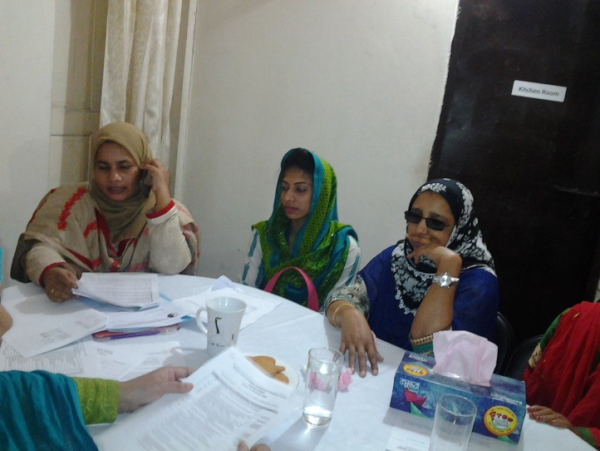The First **Executive Council (**EC) meeting was held on 18th January 2015. There were almost ten participants including office staffs. Three agenda have been discussed including miscellaneous in this meeting.

**b)** The Second **Executive Council (**EC) meeting was held on 21st March 2015. There were almost ten participants including office staffs. Three agenda have been discussed including miscellaneous in this meeting.

**C)** The Third **Executive Council (**EC) meeting was held on 28th July, 2015. There were almost ten participants including office staffs. Three agenda have been discussed including miscellaneous in this meeting.

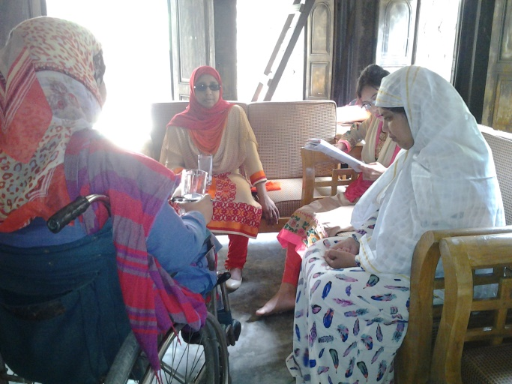**D)** The Forth **Executive Council (**EC) meeting was held on 21st August, 2015. There were almost ten participants including office staffs. Two agenda have been discussed including miscellaneous in this meeting.

**E)** The Fifth **Executive Council (**EC) meeting was held on 31st October, 2015. There were almost ten participants including office staffs. Five agenda have been discussed including miscellaneous in this meeting.

**F)** The Sixth **Executive Council (**EC) meeting was held on 19th November, 2015. There were almost twelve participants including office staffs. Seven agenda have been discussed including miscellaneous in this meeting.

G) The Seventh **Executive Council (**EC) meeting was held on 22nd December, 2015. There were almost ten participants including office staffs. Five agenda have been discussed including miscellaneous in this meeting.

**2. Grassroots Women with Disabilities Committee formation and organizing Discussion meeting with these committees:**

WDDF has formed three grassroots Women With Disabilities Committees in Three sub districts and organized Thirty two regular monthly discussion meetings including orientation along with closing programs with these committees in this reporting period.

A) The First Grassroots Women with Disabilities Committee has been formed in Daudkandi Sadar Upazila.

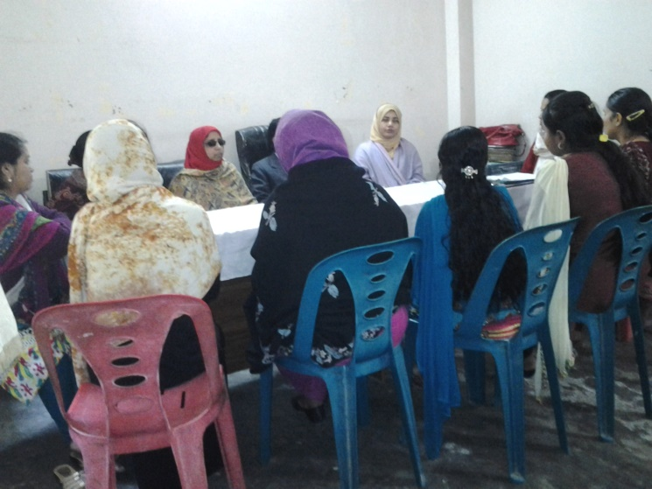B) The Second Grassroots Women With Disabilities Committee has been formed in Narayanganj Sadar Upazila.

C) The Third Grassroots Women With Disabilities Committee has been formed in Manikganj Sadar Upazila.

There are almost fifty different types of WWDs have been included in these three committees. WDDF has developed five right based modules considering the following purposes:

I) to build leadership capacity among these grassroots WWDs,

II) To make awareness among grassroots WWDs about the adopted and declared initiatives for the PWDs including WWDs by government and NGOS,

III) To inform them about the national legislation, policy, international documents, declarations and treaty about the Persons With Disabilities (PWDs) including WWDs as well as the gaps in national legislations and policy in terms of including the issue of WWDs rights,

IV) To encourage grassroots WWDs on how to transform themselves from family burden to national resource through Counseling, education and need based trainings,

V) To encourage the grassroots WWDs to become more active through enhancing their participation in decision making level of local government. Besides, number important issues have been discussed in these meetings. Viz: gender based violence, family rights violation to WWDs, multifaceted challenges in different areas, victim of double discrimination as WWDs and human rights violation to them due to lack of proper legislation and existing opportunities in different areas.

# 3. Exposure visit:

WDDF organized five exposure visits in this reporting period.

1. The First Exposure visit was being organized on 13th May, 2015, in Manikganj Disabled Peoples Organization to Development (MDPOD).  
   A number of issues have been observed and discussed between the representatives of WDDF and MDPOD. e.g. project based programs, types of existing activities, the inclusion of PWDs with the activities and future work plan.

The outcomes of this visit are:

I) To have one’s own self outsourcing for sustainability of the organization,  
II) To enhance the family support for the improvement of PWDs.  
III) To share the experience of innovative programs for the development of PWDs.

B) The Second exposure Visit was being organized on 28th June, 2015 at Linard Cheshire Disability Foundation shelter home, Uttara, Dhaka. The office staffs of WDDF were visit the Linard Cheshire Disability Foundation shelter home. They discussed with the management team in order to collect information about the activities of the shelter home. They also talked with the members about their activities.

**C) The Third exposure visit** for sharing the experience with Narayanganj DPO was being organized on 11th July, 2015 at Narayanganj DPO Office. The representatives of WDDF discussed with the Secretary of Narayanganj DPO & shared their experience. The Secretary of Narayanganj DPO is agreed to cooperate to form a grassroot women with disabilities committee in Narayanganj Sadar Upazila.

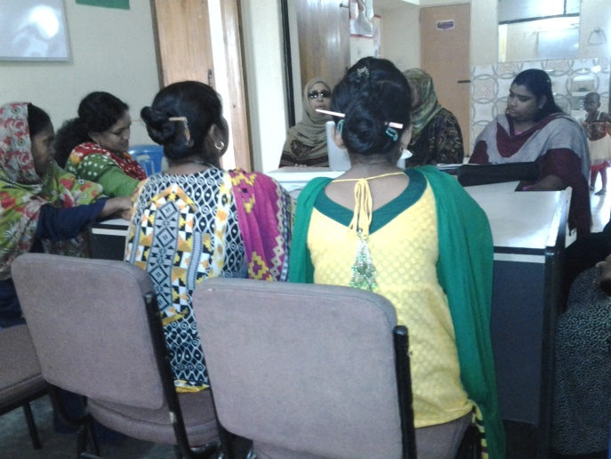**D) The Fourth Exposure** visit was being organized from 30th September to 1st October, 2015, in Sirajganj, **Sanghoti Protibandhi Nari o Shishu Sangstha**. A number of issues e.g. types of current programs, the inclusion of PWDs with the activities and future work plan have been observed and discussed between the representatives of WDDF and **Sanghoti Protibandhi Nari o Shishu Sangstha** in this visit. WDDF Chairperson, Shirin Akhter and Executive Director, Ashrafun Nahar Misti were discussed with the Executive Council Members of Sanghoti Protibandhi Nari o Shishu Sangstha. Executive Director, Ashrafun Nahar Misti presents the activities of WDDF. Accounts Coordinator Md. Hasanuzzaman and Project Officer Tahseen Showkat were also being present there and they facilitate the Executive members to fill up a sample questionnaire about the situation of WWDs. Sabina Yesmin Shila, Chairman, Sanghoti Protibandhi Nari o Shishu Sangstha presided over the meeting along with discussed their different activities in brief and 7 other Executive Council Members shared their experience about their challenges as WWDs with the representative team of WDDF.

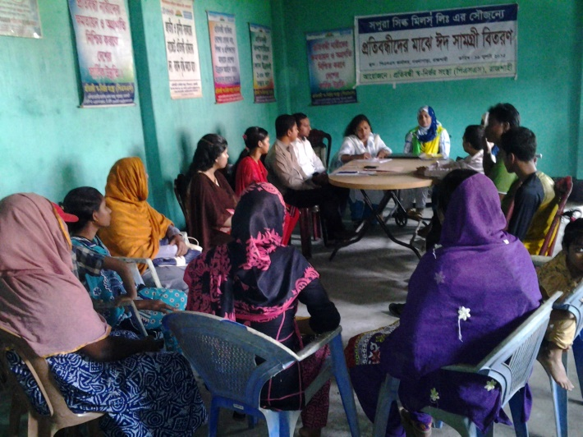**E) The Fith Exposure visit** was being organized on 17th October, 2015, in Rajshahi, **Protibandhi Sanirvar Sangstha**. A number of issues e.g. types of current programs, the inclusion of PWDs with the activities and future work plan have been observed and discussed between the representatives of WDDF and **Protibandhi Sanirvar Sangstha** in this visit.Ashrafun Nahar Misti, Executive Director, WDDF proffered a presentation about WDDF and its activities. Shirin Akhter, Chairperson, WDDF discussed about different challenges of WWDs with the Executive Council Members of Protibandhi Sanirvar Sangstha. Both organizations shared their different experience about the situation of WWDs. Accounts Coordinator Md. Hasanuzzaman and Project Officer Tahseen Showkat was also present there and visited the office activities. The NEC members of Protibandhi Sanirvar Sangstha shared their situation according to the questionnaire. Most of them are literate & having obtained their property properly from their family.

**4. Discussion Meeting with Government and Non-Government Organizations:**

The main purpose of organizing these meetings is to ensure the inclusion of Women with Disabilities (WWDs) in all newly adopted policies and plan, which had not been happened before as well as for the implementation of Government along with international rules and regulations including “UN CONVENTION ON THE RIGHTS OF PERSONS WITH DISABILITIES”.

**Seventeenth** Discussion Meetings were organized in various purposes in this reporting year (From 01 January to 31 December 2015).

A) Discussion meeting with the Additional District Commissioner (ADC) of Commilla:

WDDF has organized a discussion meeting with the Additional District Commissioner (ADC) of Commilla in DC office. WDDF representatives discussed with ADC about the activities of WDDF in Daudkandi Sadar Upazila, Comilla . After the discussion meeting The ADC of Comilla has agreed to provide the continuous support on behalf of Government to continue the activities of WDDF.

1. Discussion m**eeting with the representatives of American Centre:** A discussion m**eeting with the representatives of American Centre was being o**rganized on 26th August, 2015 at The American Center, Baridhara, Dhaka. Calvin L. Hayes, Cultural Affairs Officers, Kelly Mitchell-Clark, Public Diplomacy Officer, American Centre, Shahina Sultana Deputy Library Director of The American Center and Shirin Akhter, Chairperson,WDDF, Ashrafun Nahar Misti, Executive Director, WdDF along with the EC Members and other staff members of WDDF were present in this meeting. At the beginning of the meeting Chairperson and Executive Director of WDDF are jointly present the organizational mission, vision and activities. Other participants of WDDF have also highlighted on WDDF national level advocacy with Government and Non-Government agency. Calvin and Kelly raised different types of questions about the progress of WWDs through WDDF initiatives. Chairperson of WDDF mentioned in their presentation that, WDDF has provided different types of services to WWDs from grassroots to national level. Project Officer Tahseen Showkat mentioned that, there are three grassroot WWDs Committee formed by WDDF in 2015 at Daudkandi, Narayangonj and Manikganj.

There is also discussed about the working opportunity of WDDF & The American Center on Disability issue collectively in future.

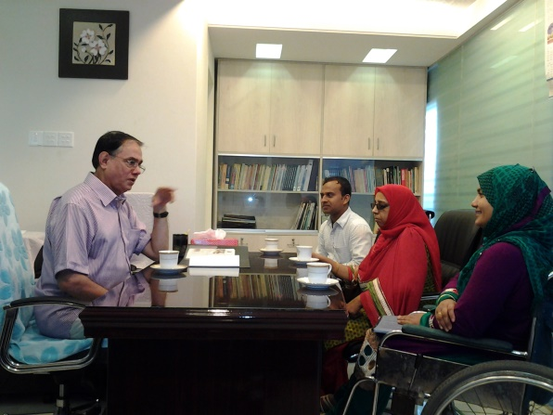C) A Discussion meeting with Shofiq Siddiq, Professor of Dhaka University was being organized on 30th August, 2015, at Accounting Department, Dhaka University. Ashrafun Nahar Misti, Executive Director, WDDF briefly discussed about the organization and its future plan. The Professor has become very happy to know the progress of WDDF and interested to extend his cooperation for its sustainability. Chairperson and staffs of WDDF were present in this meeting.

D) Discussion m**eeting with District Commissioner (DC) of Narail:**

a discussion meeting with The District Commissioner (DC) of Narail was being organized with the initiative of WDDF representatives on 6th September, 2015 at DC office,Narail. Shirin Akhter, Chairperson WDDF, discussed about the situation of Farhana Khatun with DC and DC has agreed to support the initiative of WDDF. Simultaneously, he assured to take proper initiative for achieving the justice of Victim Woman Farhana Khatun. He also said that on the basis of discussion with both Mis. Farhana Khatun and Md. Sabbir Hossain, required initiative must be taken.

E) Discussion m**eeting with the representatives of Young Bangla:**

A discussion m**eeting with the representatives of Young Bangla** was being organized with the initiative of WDDF at Dhanmondi 32 on 17th September, 2015. The representatives of WDDF present an activity report on the existing programs of WDDF. The representatives of WDDF also discussed with Young Bangla about how the issue of PWDs might be included in the activities of Young Bangla.

F) **Discussion Meeting with Additional District Majestrate (ADM) of Narail:**

**A discussion Meeting with the Additional District Majestrate (ADM) of Narail was being organized on 7th October, 2015 in DC office.**

Shirin Akhter, Chairperson, Ashrafun Nahar Misti, Executive Director, other staffs and general members of WDDF went to Narail,Jossore on 6th October, 2015 in order to adopt required initiatives including legal service support for achieving justice of victim woman With Disability Farhana Khatun, for depriving her from obtaining her family rights by Md. Sabbir Hossain. WDDF complained to District Commissioner against Md. Sabbir Hossain, who oppose to accept Farhana Khatun as his wife in public, inspite of having been married her in June, 2014 and live together as husband and wife in his relative’s house but not in his own house. In accordance with the Complain of WDDF, DC of Narail arranged an investigation under the ADM, engaging the Officer of Social Service Department and Women Affairs Department of Narail. This investigation meeting was being held on 7th October, 2015 in the presence of WDDF representative team. The investigation team asked to explain about the present situation of both Farhana Khatun & Md. Sabbir Hossain along with The ADM has also offered the opportunity to the representative team of WDDF to present their speech. After having listened The speeches of all the discussants, ADM ordered both Farhana Khatun and Md. Sabbir Hossain to submit their written complain and after that, the investigation team extended 7days for investigation & submit their investigation report.

**G) Discussion meeting with the students with disabilities of Rajshahi University**

A discussion meeting with the Students with Disabilities of Rajshahi University was being organized with the initiative of WDDF on17th October, 2015 at the auditorium of Rajshahi University. In the representative team of WDDF, Chairman Shirin Akhter, Executive Director Ashrafun Nahar Misti, Accounts Coordinator Md. Hasanuzzaman & Project Officer Tahseen Showkat were present in that meeting. On behalf of Rajshahi University a large number of students with disabilities were participated & shared their experience. 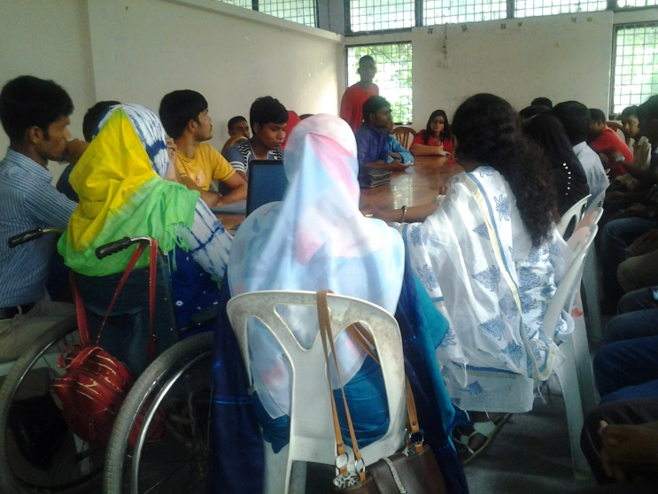 A number of issues e.g. accessible University Campus for the students with disabilities, personal experience of students, how difficulties they have to face etc were being discussed in this meeting. Ashrafun Nahar Misti, Executive Director, WDDF discussed a model of accessible university campus for Students with Disabilities. Students have also shared their experience of facing challenges in different levels. Shirin Akhter, Chairperson and Project Officer Tahseen Showkat were shared the experience of their student lives & encouraged the Students with disabilities.

**H) Discussion meeting with the representatives of Chapainawbabganj City Corporation:**

On the basis of sending divorce notice by Md. Sabbir Hossain to Farhana Khatun,

the city corporation of Chapainawbabgonj called a meeting on 16th October, 2015. The representative team of WDDF went there to participate in that meeting but the meeting didn’t hold due to the absence of Md. Sabbir Hossain.

1. **Consultation meeting with Farhana Khatun’s Family:**   
   A consultation meeting with Farhana Khatun’s family members was being organized with the initiative of WDDF on 16th October, 2015. The representative team of WDDF went to the victim Farhana Khatun’s house in Chapainawbabganj. They discussed the issue elaborately with Farhana’s family members. WDDF Executive Director Ashrafun Nahar Misti is counseling Farhana Khatun’s family members. Chairmen Shirin Akhter and other staff members also were present there & counseling the victims family members.

**J) A couple of discussion meetings from 26th October to to 29th October, 2015 in Narail for providing cooperation to get justice of Farhana Khatun:**

**I) Discussion meeting with Assistant District Commissioner (ADC) (Revenue) of Narail:**

A d**iscussion meeting with the Assistant District Commissioner (ADC) (Revenue) of Narail was being organized with the initiative of WDDF on 26th October, 2015.** ADC (Revenue) Rayhan Kawser said that he has already informed the issue of Farhana Khatun but the investigation report hasn’t been submitted yet. he called the officer of Women Affairs Department & told WDDF team that initiative has been taken. He also said that the administration must be supportive to Farhana Khatun.   
**II) Discussion meeting with the representatives of a number of NGOs:** 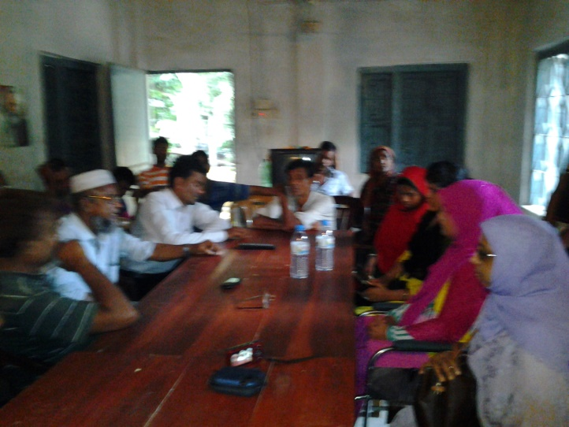

A d**iscussion meeting with the Executive Directors of a number of NGOS in Narail was being organized with the initiative of WDDF on 27th October, 2015.** Viz:

Kazi Hafizur Rahman, Executive Director, Sabalambi, Afroza Khatun, Executive Director, Asher Alo Foundation, Representatives of BRAC and Proshikha. All of them are supported the initiatives of WDDF & assured that, they must provide their all types of cooperation to get justice of Farhana Khatun against the cheating of Md. Sabbir Hossain, through opposing to accept Farhana as his wife.

K) Discussion m**eeting with Member of Parliament (MP) of Narail:**A d**iscussion meeting with** Shiekh Hafizur Rahman, MP,  **Narail was being organized with the initiative of WDDF on 28th October, 2015.** Ashrafun Nahar Misti, Executive Director, WDDF explained the whole situation of Farhana Khatun elaborately. After having heard the 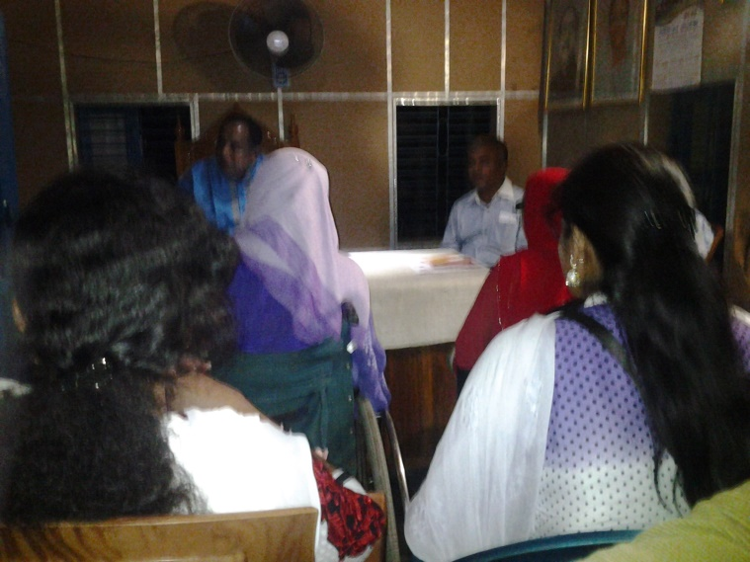overall situation, MP Shiekh Hafizur Rahman told that Md. Sabbir Hossain violated the human rights of Farhana,he should be punished. He also said that initiatives must be taken against Md. Sabbir Hossain simultaneously for getting justice of Farhana Khatun. He also has supported the decision and activities of WDDF.

L) Discussion meeting with legal aid support providing organization:

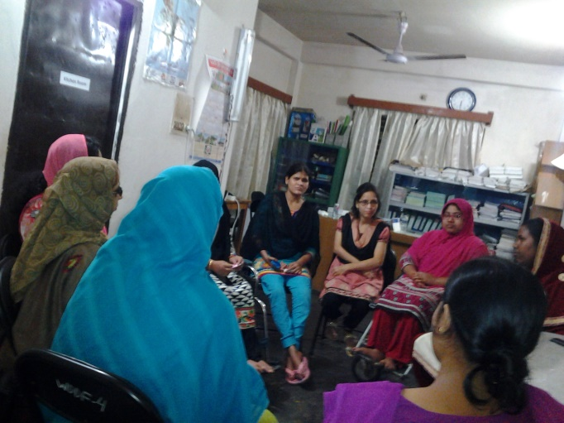A d**iscussion meeting with the lawyers of** Ain o Salish Kendro(ASK), a well reputed women along with hiuman rights based and legal aid support **service providing organization was being organized with the initiative of WDDF on 15th November, 2015 in its own office.** Chairperson Shirin Akhter and Project Officer Tahseen Showkat participated in this meeting and discussed the issue of WDDF general member Farhana Khatun who had been deprived from the family rights. The lawyer of ASK suggested some important advice regarding this issue. She said that at first Farhana Khatun would be complained against her husband Md. Sabbir Hossain as he violated her women & family rights. According to the suggestion, Farhana Khatun has appeared in ASK and the advocate of ASK discussed with Farhana Khatun as well as entry her name as victim**.** She also said that they called her husband Sabbir Hossain for mutual with other through salish. Chairperson Shirin Akhter said that we should take initiative for protecting her dignity & rights as a woman.

M) Discussion m**eeting with Upazila Nirbahi Officer (UNO) and the Officer of Social Service Department, Narayanganj:**

A discussion m**eeting with the Upazila Nirbahi Officer (UNO) and the Officer of Social Service Department of Narayanganj** was being organized with the initiative of WDDF on 2nd December, 2015 in their office. Chairperson Shirin Akhter and Project officer Tahseen Showkat were present in this meeting to discuss the importance of working with the grassroot WWDs in district and subdistrict level with them. Both the representatives of WDDF discussed about the activities of WDDF with them in Narayanganj Sadar Upazila and invited them in the closing ceremony of the program of WDDF as the Chief guest and special guest. Both UNO Afroza Chowdhury Chumki & Social Service Department Officer Shila Shaha have agreed to present in this program.

N) Discussion m**eeting with the Upazila Nirbahi Officer (UNO) and the Officer of Social Service Department, Daudkandi:**

A discussion m**eeting with the Upazila Nirbahi Officer (UNO) and the Officer of Social Service Department of Daudkandi** was being organized with the initiative of WDDF on 6th December, 2015 in their office. Chairperson Shirin Akhter and Project officer Tahseen Showkat were present in this meeting to discuss the importance of working with the grassroots WWDs in district and subdistrict level with them. Both the representatives of WDDF discussed about the activities of WDDF with them in Daudkandi and invited them in the closing ceremony of the program of WDDF as Chief guest and special guest. Both UNO Asaduzzaman and Social Service Department Officer Md. Shibli Zaman have agreed to present in this program.

O) Discussion m**eeting with the Upazila Nirbahi Officer (UNO) and the Officer of Social Service Department, Daudkandi:**

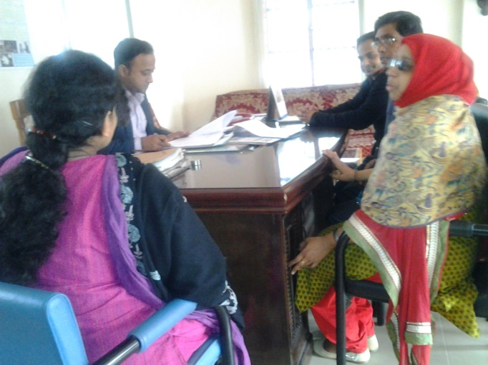A discussion m**eeting with the Upazila Nirbahi Officer (UNO) and the Officer of Social Service Department of Manikgonj** was being organized with the initiative of WDDF on 16th June, 2015 in their office. Chairperson Shirin Akhter and Project officer Tahseen Showkat were present in this meeting to discuss the importance of working with the grassroots WWDs in district and subdistrict level with them. Both the representatives of WDDF discussed about the activities of WDDF with them in Manikgonj.

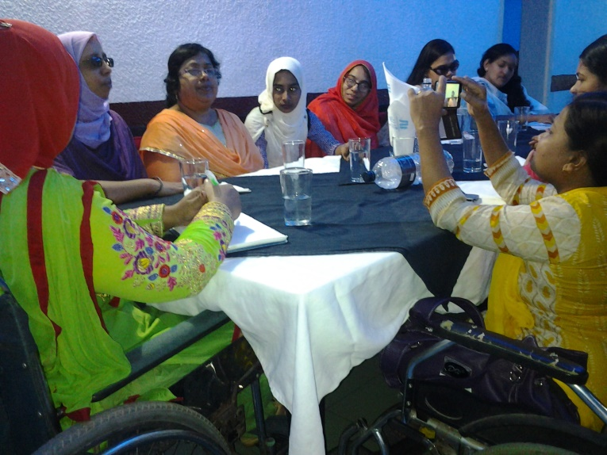P) **Discussion Meeting with the women leaders with disabilities:  
A discussion Meeting with the women leaders with disabilities was being organized with the initiative of** WDDF, on the occasion of observing 3rd December, 24th “International Day of Persons With Disabilities” and 17th “National Disability Day of Persons With Disabilities” on 5th December, 2015, at City garden, Chinees Restaurant, Shishumela,Dhaka. Women leaders with disabilities of Seven women led organizations including WDDF Chairman Shirin Akhter & Executive Director Ashrafun Nahar Misti were present in this meeting. Mohua Paul, Vice Chairperson, Access Bangladesh Foundation presided over the meeting. They discussed about their success, position, barriers & negative attitudes of their colleagues and other people. The entire participants discussed that this is a time required initiative of WDDF to organize such a meeting & agreed to continue this meeting after every two months. They have also decided to take initiative to observe the International Women Day, 8thMarch, 2016. General members and other staffs of WDDF were also present there.

**P) Discussion meeting on Gender Based Violence:**

A discussion meeting on Gender based Violence with the EC along with the General Members of WDDF, on the occasion of Prevention of Violation against Women period (From 16th to 25th November, 2015 was being organized with the initiative of WDDF on 25th November, 2015 at WDDF office. All EC and General Members of WDDF were participated in this meeting. They have shared their experience about the violence they have to face in every moment of their daily lives and various types of violations are being happened against girls and Women with disabilities. Shirin Akhter, Chairperson presided over the meeting. Executive Director Ashrafun Nahar Misti discussed about the issue and Project officer Tahseen Showkat facilitated the meeting. WDDF Vice Chairman Masuma Akhter said that WWDS should be concerned about their dignity and rights. She also told that WWDs should aware about the violence and how to protect themselves from this violence; otherwise they and their family were suffering. Chairman Shirin Akhter Shared an experience of a WWD who had been violated from a mail leader with disabilities. Project Officer Tahseen Showkat also has shared her personal experiences when she called an interview for job in a renowned organization. General member Farhana Henna also described how her family and human rights are violated by her husband and male leader with disabilities. WDDF members become committed not to tolerate any types of violation against girls and Women with disabilities as well as PWDs.

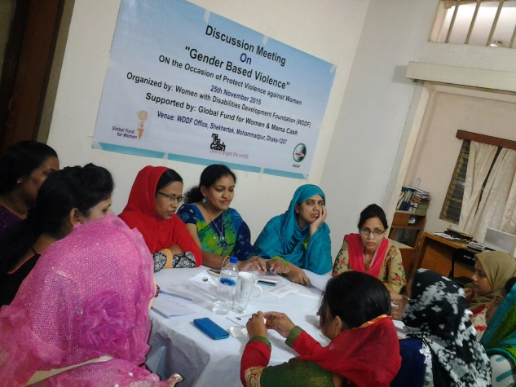

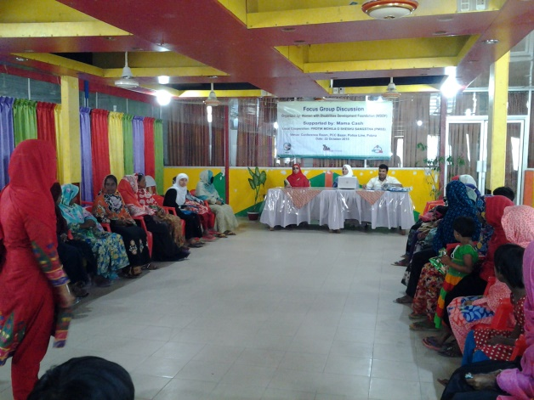5. Focus Group Discussion: **A focus group discussion (FGD)** with the beneficiaries of Protik Mohila O Shishu Sangstha (PMSS) was being organized with the initiative of WDDF on 22nd October, 2015 at the Conference hall, PCCS Bazar, Police Line, Pabna. Md. Saifur Rahman, Executive Director, PMSS locally cooperated with WDDF to conduct this program. Thirty WWDs participated in this FGD. Among these Thirty beneficiaries, there are 14 women are physically challenged, 5 women are visually impaired, 5 women are intellectual disable, 3 women are multiple Disabled, 1 women is Down syndrome and 2 women are hearing and speech impaired. Ashrafun Nahar Misti, Executive Director, WDDF offered a presentation about the activities of WDDF and discussed about it’s future plan. She also had a conversation about the situation of WWDs of Pabna with the participants. Shirin Akhter, Chairperson expressed her sincere thanks on behalf of WDDF for the spontaneous cooperation and participation of all participants. She also has mentioned that WDDF always raises strong voice for the proper inclusion of WWDs in every aspects of the society. Md. Saifur Rahman, Executive Director, (PMSS) encourages the activities of WDDF and also mentioned that in future PMSS will be work with WDDF for the development of WWDs. After that Accounts Coordinator Md. Hasanuzzaman and Project Officer Tahseen Showkat distributed questionnaire and help them to fill up this questionnaire. Every participant has to fill up a questionnaire about their situation in different aspects.

6. One Stop Crisis Centre (OCC) of Divisional Medical Colleges visit:

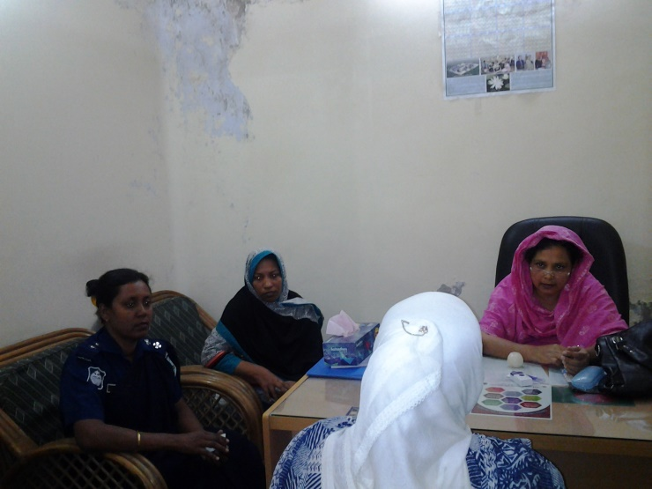A) **One Stop Crisis Centre (OCC) of Rajshahi Medical College and Victim Support Centre Visit:**

WDDF representative team visited One Stop Crisis Centre (OCC) and organized a discussion meeting with the authorities of OCC, Rajshahi Medical College and Victim Support Centre on 18th October, 2015. Chairmen Shirin Akhter, Executive Director Ashrafun Nahar Misti and Project Officer Tahseen Showkat were present in this meeting. They discussed about the services of OCC and also mentioned that if any WWDs have come here they should arrange special take care for their physical, mental and legal support and cure. They have also suggested maintaining registration system and preserving the information in order to collect data of victim WWDs. The officers of OCC have agreed with WDDF about the special care for victim WWDs.

B) **One Stop Crisis Centre (OCC) of Chittagong Medical College and Victim Support Centre Visit:**

WDDF representative team has visited One Stop Crisis Centre (OCC) and 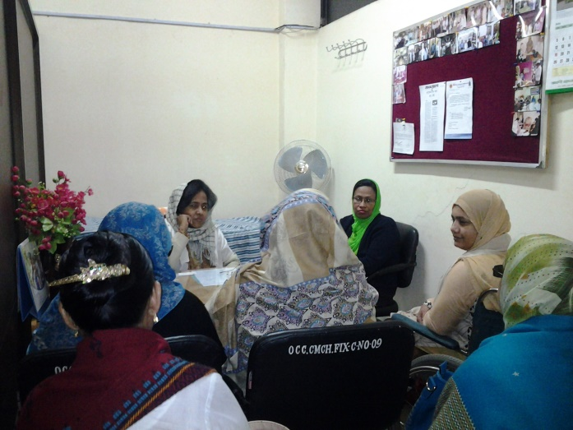organized discussion Dr. Marufa Nigar, in-charge of One Stop Crisis Centre of Chittagong Medical College on 23rd December, 2015. Chairmen Shirin Akhter, Executive Director Ashrafun Nahar Misti EC Members Safiya Begum, Sharifa Tarafdar, General Member Jahanara Hena and Project Officer Tahseen Showkat were participated in this meeting. There was half an hour discussion with WDDF team. The main points are discussed about the rehabilitation program for WWDs.They discussed about the services of OCC and also mentioned that if any WWD has come here for support they should arrange special take care for their physical, mental and legal support and cure. They have also suggested maintaining registration system and preserving the information in order to collect data of victim WWDs. The officers of OCC have agreed with WDDF about the special care for victim WWDs.

7. **National Consultation on “Participation of Persons with Disabilities In Mainstream Developmen**t”**:**

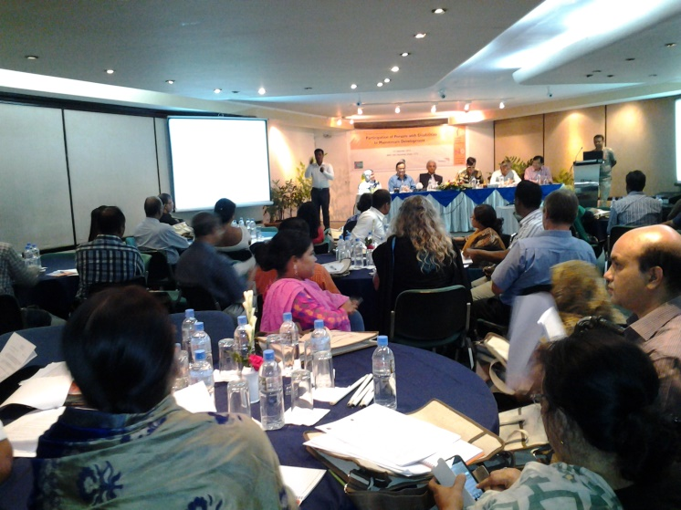A National Level Consultation on “Participation of Persons with Disabilities in Main stream Development” was being organized by Women with Disabilities Development Foundation (WDDF) in join collaboration with World Vision Bangladesh and Centre for services and Information Dissemination (CSID) on 16th September, 2015, at BRAC Inn Center, Mohakhali, Dhaka. Ashrafun Nahar Misti, Executive Director of WDDF has delivered Welcome speech. Mr. Monsur Ahmed Chowdhury,Member,Executive Board,Disability Council International & Former committee member, of Bangladesh UN convention on Rights of Persons with Disabilities and Md. Jahidul Kabir,National Advocacy Coordinator (Education & Disability Inclusion) World Vision Bangladesh were jointly present the key note paper of the National Consultation. Professor Dr. Gowher Rizvi, International Affairs Adviser to the Honorable Prime Minister was present as a chief Guest. Mr. Kazi Reazul Hoque,Full Time member of National Human Rights Commission (NHRC) was present as a special Guest of the Consultation. Md. Jahidul Kabir, National Advocacy Coordinator (Education and Disability Inclusion) World Vision Bangladesh, said that Disability is a cross-cutting issue as well as an issue of considering the inclusion of a huge number of populations which is around 15%. So, if World vision has been expanded its activities without considering the issue of inclusion of Persons with disabilities in mainstream properly, it won’t be possible to reach in the desire goal of development.

There was open Discussion. Shirin Akhter, Chairman of WDD, Vashker Vatta Charya, Jibon Willium Gomes and many other discussants were expressed their opinions on how PWDS might be included in Mainstream Development. It was an effective initiative to include PWDs in mainstream development.

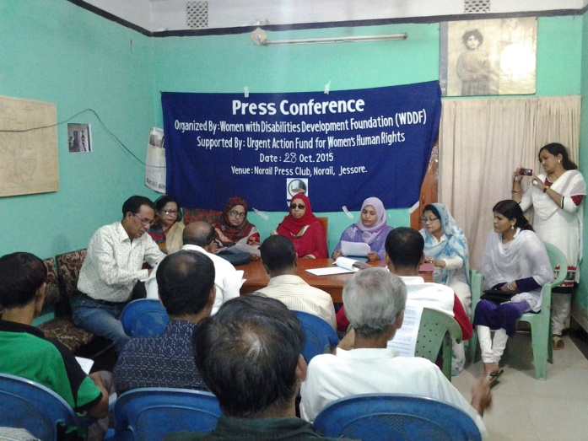8.**PressConference:**   
A press Conference for getting justice of violation of women, human rights along with family rights of a WWD, with the initiative of WDDF was being organized a **Press Conference** held on 28th October, 2015 at Narail Pressclub. WDDF Chairman Shirin Akhter delivered the welcome speech; Executive Director Ashrafun Nahar Misti presents the keynote paper. Both Chairmen and Executive Director of WDDF answer the queries of journalists. Rabeya Yusuf, Secretary General,Zila Mohila krira Sangstha, Advocate . Rowshan Ara kabir Lili, Afroza Khatun, Executive Director, Narail Asher Alo Foundation, besides, representatives of NGOs and CSOs were also present in that press conference.

**9. Annual General Meeting (AGM):**

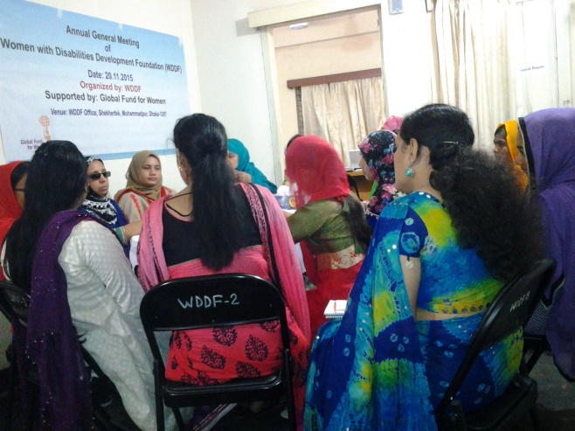Annual General Meeting (AGM)of WDDF was being organized on 20th November, 2015 at WDDF office. The meeting has started at 9.00am. WDDF Chairperson Shirin Akhter presided over the meeting. Executive Director Ashrafun Nahar Misti facilitated the meeting and previous meeting resolution was proposed by the General Members Farhana Khatun and Supported by Afroza Akhter Nipa along with Beauty Begum for approval. General members approved the meeting Minutes. On behalf of Treasurer SuraiyaAkhterBably, with her permission over phone, Executive Director submitted the financial report and audit report along with proposed budget for next year. Executive Director also presents the Annual report and next year Work plan of WDDF. A number of activities are included in next year Work plan.

**10. Dialogue on Human rights of Women with Disabilities:**

A dialogue entitled “Human rights of WWDs” on the occasion of observing the International Human Rights Daywas being organized with the initiative of WDDF in collaboration with the American Centre on 10th December, 2015 at the American Centre auditorium. Kelly Mitchell Clark, Public Diplomacy Officer, the American Centre Welcome all the participants and invited for an introductory session of them. Shirin Akhter, Chairperson, WDDF has delivered the welcome speech.   
  
A video message from Judith Heumann, Special Advisor for International Disability Rights (SADR), U.S.State Department has shown through multimedia.  
Ashrafun Nahar Misti, Executive Director, WDDF was present the keynote paper on the Current Status of Women with Disabilities in Bangladesh. She also discussed about what types of important human rights violation have to face by WWDs & what type of progress has been made from the assessment (2010).

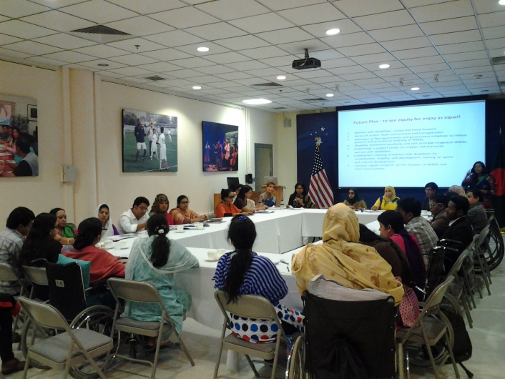There was an open Discussion, Jibon William Gomej, Executive Director, Turning Point Foundation, Nazrana Yesmin Hira, Coordinator on disability issue, Manuser Jonno Foundation (MJF), Nazma Ara Begum Popy, General Secretary, Bangladesh Visually Impaired Peoples Society (BVIPS), and many other discussants were expressed their opinions about the violation of human rights of PWDs especially WWDs. There was also a session on experience sharing about the education rights of girl’s students with disabilities and family rights violation. WDDF general member Farhana Khatun shared her family rights violation, how she was deprived from her husband. All participants were divided in to three groups in the group work session and discussed about what type of advocacy & sensitization strategies are needed to make the environment where WWDs are able to realize their rights and protect themselves from GBV and they also present the three sets of findings of group works such as-  
I) what type of activities are the organizations currently doing to address the needs of WWDs?  
II) What types of activities are these organizations interested to do?  
III) Are they interested in working with other organizations focused on the needs of WWDs?   
This discussion has moderated by Shahina Sultana, Deputy Library Director, The American Centre.

Anna Frank, Director, The American Centre has delivered recognition speech at end of the program. Kelly Mitchell Clark has delivered vote of thanks.

11. Education Scholarship and support for Income Generating Activities (IGA) distribution programs: **Four** Education Scholarship and Two support for Income Generating Activities (IGA) distribution programs were being organized with the initiative of WDDF **in December,**

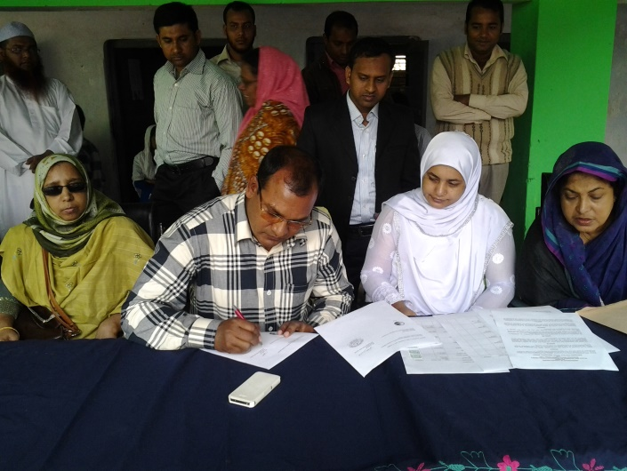**2015, are as follows:**

A) The first education scholarship distribution program with the initiative of WDDF, was being organized on 29th November, 2015 at Jhikargacha Pilot Girls’ High School,Jossor. WDDF and the school Committee have signed a MOU for one year. The school Committee has taken responsibilities to provide all types of cooperation towards girl’s students with disabilities which is really very helpful for them. WDDF has distributed scholarship among Seven Girls’ With Disabilities. WDDF & the school Committee have taken decision that in january’16 1500tk will be distributed for every girl student with disability for their school dress, new books and other necessaries then 5hundrad tk will be given in each month (From February to December2016) as scholarship.

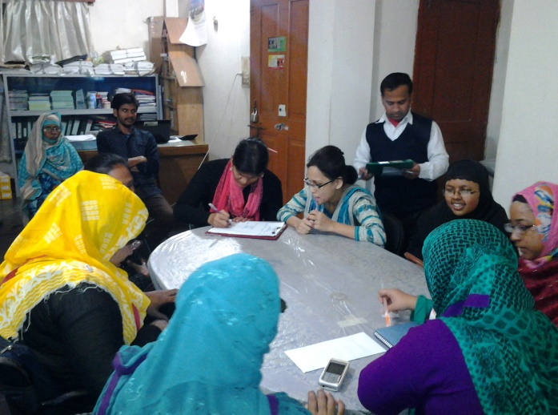B) The 2nd Education Scholarship distribution program with the initiative of WDDF was being organized on 20 December, 2015 at WDDF office. Education scholarship is being distributed among Nine girls students with disabilities of different University in this program. WDDF Chairman Shirin Akhter& Executive Director Ashrafun Nahar Misti have a short discussion for their encouragement.

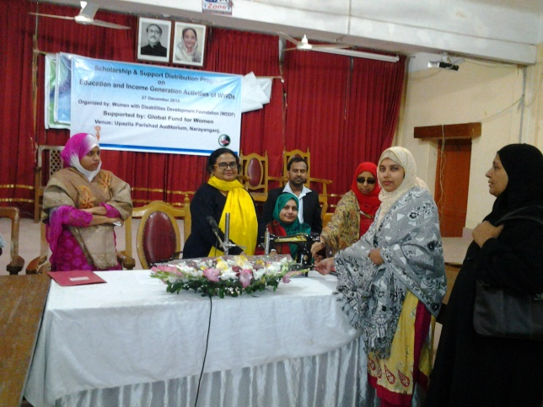C) The 3rd Education Scholarship and 1st support for Income Generating Activities (IGA) distribution program with the initiative of WDDF, was being organized on 27th December, 2015 at UpazilaParishadAuditorium,NarayanganjSadarUpazila, Narayanganj. Education scholarship is being distributed to One girl student with disability of National University and IGA support is being distributed among Eight women with disabilities in this program. WDDF is working hard to support for building discrimination free lives of WWDs with equal dignity. Shila Shaha, Social Service Officer of NarayanganjSadarUpazila was present as chief guest. HabibYasmin,Officer, Assistive Device along with service providing Centre for Disability as special guest in this program.

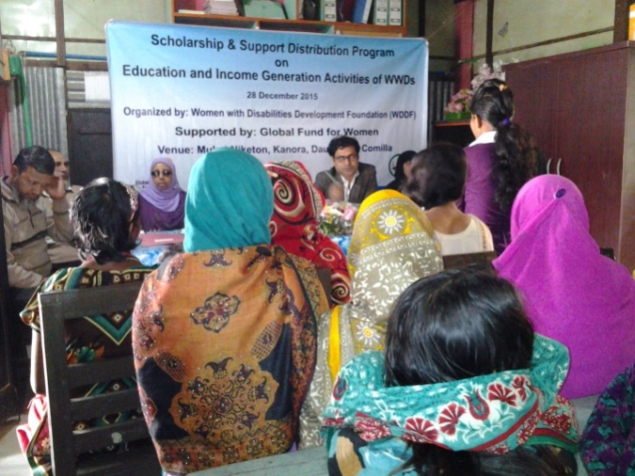D) The 4th Education Scholarship and 2nd support for Income Generating Activities (IGA) distribution program with the initiative of WDDF, was being organized on 28th December, 2015 at MukulNiketan, Kanora,Daudkandi,Comilla. Education scholarship is being distributed among five girls students with disabilities of different schools and IGA support is being distributed among Seven women with disabilities in this program. WDDF is working hard to support for building discrimination free lives of WWDs with equal dignity.

Md. Shibli Zaman, Social Service Officer of Daudkandi Comilla was present as chief guest.

He said that WDDF has taken a good initiative but they should have to continue their supervision over the beneficiaries.

12. **Training on Reproductive health Rights of Women With Disabilities:**A training on **Reproductive health Rights of Women With Disabilities** was being organized with the initiative of WDDF on 22nd December, 2015, at PTI SHOP, Ispahanimore, Lalkhanbazar, Chittagong. Shirin Akhter, Chairperson, WDDF delivered her welcome speech, Ashrafun Nahar Misti, Executive Director, WDDF facilitated the training. Abida Azad,

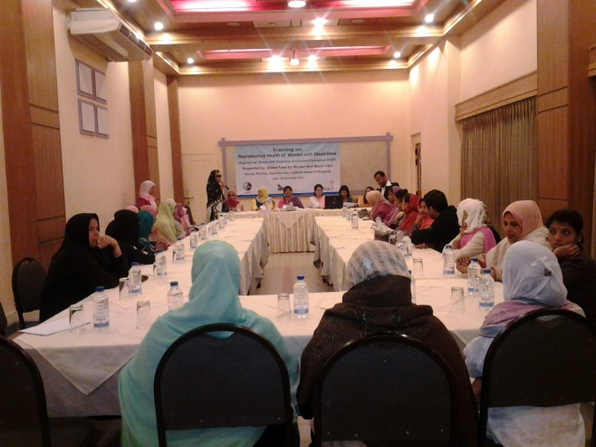Ward Commissioner,Chittagong, was present in this program as Chief guest and Paruma Begum, Social Service Department Officer, was present as Special guest. Khaleda Begum, Chief trainer, Yong Power in Social Action (YPSA) was led the training and Resource person was Farhana Idris. Thirty WWDs were participated in the training. All The participants including guests & WDDF staffs have learned many important issues about reproductive health. All participants have agreed that it is an effective training for them & they have shown interest to continue this training subsequently and for long time.

Part B

**Participation in different Governmental and Non-Governmental programs/events:** The officials as well as staffs of WDDF participated in different Governmental/Non-governmental programs/events. Viz:

**1. International Programs:**

**WDDF representative participated in the following international programs in this reporting year.**

**a)** A four day International Conference on Advisory Committee was being organized by Urgent Action Fund for Women Human Rights from 23rd to 27th February, 2015,in Nepal.

**b)** 59th session on Commission on the Status of Women (CSW) was being held from 8th to 18th March, 2015, in New York ,United States of America.

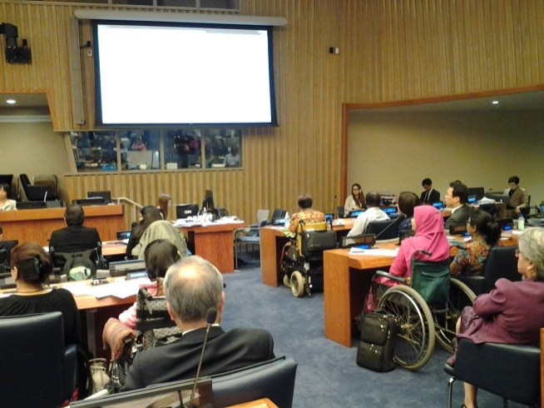**C)** International State parties conference on CRPD was being held from 8th to 12th June, 2015 in New York, United States of America.

After joining those programs wwds issues are being well accepted in international documents and some positive changes indicate more representations are needed in the international communities. WDDF has signed join paper on world humaniterian summit and submitted recommendation to include disability issues in coming statement on world humanitarian summit 2016.

1. **Discussion Meeting/ Experience sharing meeting:**

WDDF participated in 21 **Discussion Meeting/ Experience sharing meeting** in this reporting period.

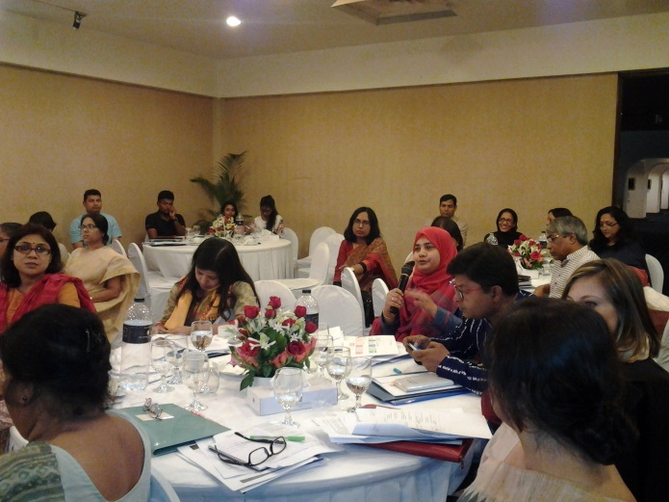A) **A pre preparation meeting on 59th session of Commission on the Status of Women (CSW)** was being organized on 22nd February, 2015, at Bangabondhu International Conference Centre. A number of important rights of women e.g. rights of workers women, migrant women & the situation of women in policy & political level were being discussed in this meeting. The issue of WWDs was not being included in this meeting but due to raising our voice on behalf of WDDF, the representatives of civil society groups are agreed with us That the issue of WWDs should be included in the report of CSW and the state minister of Women & Children Affairs Ministry promised that this issue would be included in this report.

B) A Thematic Group Meeting on the Rights of WWDs was being organized by National Forumm of Organizations Working With the Disabled (NFOWD) in it’s own office, at 10.00 A.M, on 24th February, 2015.

**C)** A discussion meeting on the situation of improvement of WDDs was being organized by Disability Rights Fund on 3rd March, 2015, at Centre Point Hotel, Gulshan2. An elaborate discussion on the situation of WWDs has been discussed by Ashrafun Nahar, Executive Director, and WDDF.

**D)** A discussion meeting on Legal Aid Support for WWDs, was being organized by Bangladesh National Women Lawyers’ Association (BNWLA) in it’s own office, on 15th March, 2015. With the active participation and recommendation of Ashrafun Nahar, Executive Director, WDDF, A few important issues e.g. In What ways WWDs can get legal aid support easily?

* What type of legal aid support they are needed?
* Is legal aid support available for them in every area?  
  etc. are being discussed elaborately in this meeting.

**E)** A Meeting on Rules Committee for PWDs Rights & Protection Act 2013 was being organized by National Forumm of Organizations Working with the Disabled (NFOWD) in it’s own office, on 8th April, 2015.

Ashrafun Nahar, Executive Director, WDDF, raised her strong voice about the issue of inclusion of WWDs in the related areas of rules in this meeting.  
F) A discussion meeting on Violence Against Women was being organized on 26th April, 2015, at R.C. Mojumder Auditorium, University of Dhaka**.** Ashrafun Nahar, Executive Director, WDDF, told that, WDDs are become victim of violence more than able bodied women and it is very difficult for them to get proper justice after violation due to their disabilities. So the causes of violence against WDDs and the barriers of getting proper justice are being discussed as well as the important issue is also being discussed, how it is possible to provide time required legal aid support for them.

**G)** A Meeting on disability and sexuality was being organized by Turning Point Foundation in it’s own office, on 18th May, 2015. The issue of disability and sexuality especially for the women with disabilities was being discussed elaborately in this meeting. This meeting is for the first time sharing meeting for WWDs to share such type of experience issues. All the participants of this sharing meeting discussed their life experience before & after marriage as well as different types of complexity of family relation & family building. Actually it was an experience sharing meeting & it is decided that time required initiative should be adopted on this issue on behalf of PWDs in future.   
**H)** A project launching ceremony on Feed the Future Bangladesh Women’s Empowerment Activity was being organized on 26th May, 2015 at Emmenullah’s Convention Centre, house#08, road#04, Gulshan-1. It is a project launching program of the women empowerment project with the inclusion of women with disabilities.

**I)** A Discussion Meeting in order to create Policy, Environment and Positive attitude towards Employment opportunity for the Women With Disabilities, with the Authority of Bangladesh Garments Manufacturing Export Association (BGMEA) was being organized with the initiative of National Council for the Disabled Women (NCDW) on 28th June, 2015 at BGMEA Bhaban,Kawranbazar,Dhaka. Due to raising our voice strongly, the authority of BGMEA has agreed that, if the organizations of WWDs send a list of women workers with disabilities to them; then BGMEA will take initiatives to make disability friendly environment and to create employment opportunity for them.

**J)** A Discussion Meeting on Education, Equal Justice and Protection against Gender based Violence of Persons with Autism, Intellectual and Multiple Disabilities was being organized by SEID Trust in collaboration with Bangladesh Protibandhi Foundation (BPF) and Steps towards Development (STD) on 11th August, 2015, at Azimur Rahman Conference Hall, Dailystar Bhaban. Shirin Akhter, Chairperson, WDDF, told that, It is difficult to identify them &to inform their situation as their family are not interested to bring them outside or not to introduce with others due to their safety. She also recommended that, They should be included in the main stream of development. We should take initiative such as to increase their family values, to aware them about their situation, types of disabilities should be included in birth registration form.

**K)** A Sharing Meeting for sharing the experience of organizing a Summer Camp in June, 2015, with the representatives of American Centre was being organized with the initiative of Physically Challenge Development Foundation (PDF) on 16th August, 2015 at American Centre, Baridhara, Dhaka. They mentioned that it was a great opportunity to work for people especially young generation were included in this camp. It was a good initiative to grow awareness about a number of issues E.G. education, IT, traffic signal, safe water & sanitation. Ashrafun Nahar, Executive Director, WDDF, suggested them to use appropriate disability terminology to address PWDs properly.

**L) A pre-preparation Meeting in order to Organize a National Consultation on Participation of Persons with Disabilities In Mainstream Development in join collaboration,** was being organized on 18th August, 2015, by World Vision in it’s own office. WDDF,CSID and World Vision are going to organize a national consultation on participation of PWDs in mainstream development jointly which will be held on 16th September, 2015. Executive Director AshrafunNahar, KhondokerJohurulAlam&Mo.Jahidul Kabir were present in this meeting. They discussed about the program schedule, primary participation list.

**M)** **A pre-preparation Meeting in order to Organize a National Consultation on Participation of Persons with Disabilities In Mainstream Development in join collaboration,** was being organize on 19th August, 2015 by Centre for Services and Information Dissemination (CSID) in it’s own office. This was the second meeting on upcoming National Consultation. Organizers are discussed about the chief guest, special guest, finalized the participant list and other issues E.G. invitation card, email and banner. Executive Director AshrafunNaharMisti discussed about the participation of PWDs in different criteria.

**N)** A service committee meeting for inspection of Venue for Dhaka Conference was being organized on 23rd August, 2015 at Krishibid Institute, Farm gate. WDDF & other subcommittee members of Dhaka Conference were visited the Krishibid institute as a venue of Conference. They visited the auditorium, hall room, and cafeteria and toilet facilities. They have come to a decision that some changes are needed for easy accessibility for PWDs**.**

**O)** A Discussion Meeting on Family Building and Sexuality of Women with Disabilities was being organized on 24th August, 2015, by Turning Point Foundation in it’s own office. The issue on family building and sexuality especially for the women with disabilities was being discussed elaborately in this meeting. All the participants of this discussion meeting were discussed their life experience before & after marriage as well as different types of complexity of family relation and family building. Actually it was the 2nd time experience sharing meeting and it is decided that time required initiative should be adopted on this issue on behalf of DPOs in future.

**P)** A Meeting on Gender Analysis of Economic & Social Cost of Local Climate Change in Bangladesh was being organized by Steps towards Development (STD), on 30th August, 2015, at CIRDAP Auditorium.

**Q)** A National Sharing Meeting on SDG: Bangladesh Position & Way Forward was being jointly organized by STEPS towards Development (STD), Save the Children, World Vision Bangladesh, BRIT and SERAC Bangladesh on10th September, 2015, at CIRDAP Auditorium. AshrafunNaharMisti, Executive Director, WDDF raised her voice about the disability issues. The issue of WWDs should be included as an emerging issue. The Special Guest of this meeting thanked her for drawing attention on disability issues.

**R)** A Discussion Meeting in order to make Employment Opportunities for WWDs, with Bangladesh Knitware and Manufacturing Export Association (BKMEA) Authority was being organized with the initiative of National Council for Disabled Women (NCDW) on 13th September, 2015 at Planners tower, Banglamotor, Dhaka. Project Officer TahseenShowkat said that WWDs have the rights of employment opportunity. They should be included as a part of development. BKMEA authority has also agreed with this discussion & assured that they will take the initiative for WWDs employment opportunities.

**S)** A Discussion Meeting on Implementation of Article 31 &36 of “Rights& Protection Law of Persons with Disabilities -2013” was being organized by Better Work for Bangladesh, on 14th October, 2015 at national press club.

T) an experience **Sharing of Study Findings: on health rights of PWDs** Gaps in Policy and Institutional Processes**,was being organized** on 22nd November, 2015 at LGED-RDEC Auditorium,Agargaon,Dhaka. The objective of this study is to explore the gaps in health policies and practices regarding the health and rehabilitation services of Persons with Disabilities with health systems in Bangladesh.

U) An experience sharing meeting on Developing Effective Measures to prevent Sexual Harassment in Tertiary Education Institution was being organized by UN Women, Bangladesh, on 3rd October, 2015, at Bangabondhu International Conference Centre. Executive Director Ashrafun Nahar Misti and Project Officer Tahseen Showkat of WDDF participated in this program. Seven real life stories of seven women rights activists from Nigeria, Afghanistan, Guatemala, Russia, Pakistan, Ireland and Cambodia were present, every time performed by seven new persons who themselves represent different aspects of society; politicians, activists, athletes, journalist & survivors. Each performance is make collaboration among stakeholders with the issues from civil society, government agencies, municipalities, student organizations etc. Ashrafun Nahar Misti Executive Director of WDDF said that WDDF will collect this documentary & present it in different districts for WWDs. They would be developed and gather experience from this. She also said that this play represents the different difficult situations of women as well as WWDs together.

1. 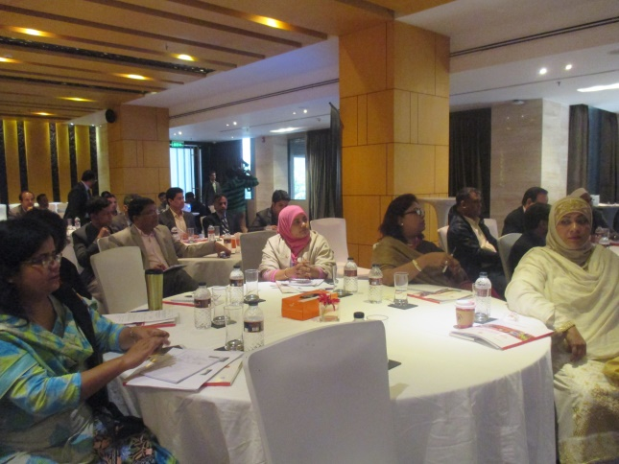Workshop:

WDDF participated in Six Workshop in this reporting period.

A) The 1st workshop on Inclusion of PWDs in Employment was being organized on 10th January, 2015 at Hotel Inn Quality, Gulshan-2,Dhaka. The representatives and participants of this workshop are agreed that Employment is a basic need of PWDs. Raising our voice strongly, we said that some skillful training should be adopted for PWDs from Government & NGOs. These trainings will help PWDs as well as WWDs to choose comfortable job for them.

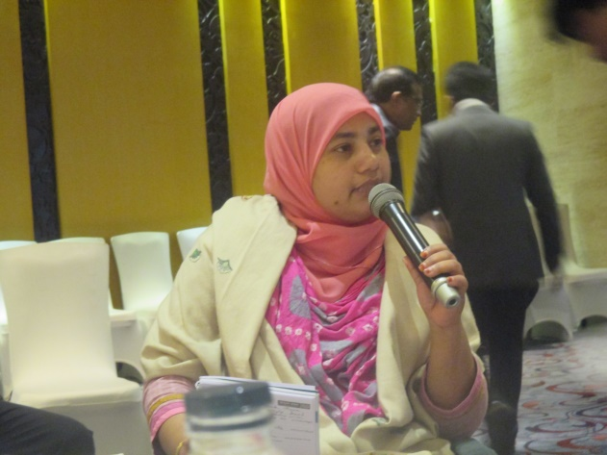 B) The 2nd w**orkshop on Disability Inclusion and Green Jobs in Tourism and Hospitality Sector** was being organized on 7th March, 2015, at BRAC Centre Inn, Mohakhali, Dhaka. About the initiatives on the inclusion of WWDs in Tourism and Hospitality Sector were being tried to explore in this workshop.  
The representatives and participants of this workshop are agreed that this is the potential sector for PWDs & through the appropriate initiatives of the relevant authorities; PWDs can contribute in the improvement of the country through their active participation in this sector.

C) The 3rd **Workshop on the Rules of PWDs rights and Protection Act 2013 (Draft)** was being held on 13th April, 2015, at CRP Bhaban,Mirpur-14,Dhaka. WDDF participated in the workshop as a consultative member of the rules committee. The issues on how PWDs will be able to achieve their rights and in what ways their rights will be protected are being discussed elaborately in this workshop. About the different initiatives of making the rights of PWDs enjoyable & as if they don’t deprive from their rights are also being discussed.

**D) The 4th workshop entitled Sensitization workshop for DPOS and Self Advocacy group on Inclusive Approach** was being organized on 23rd April,2015, At LGED Bhaban,Agargaon,Dhaka. The process and approach of how the persons with disabilities are being included in the main stream level with the cooperation of DPOS and Self Advocacy group are being discussed in this workshop.

**E) The 5th Workshop on Disability Inclusion in Hospitality and Tourism Sector** was being organized on 30th May, 2015 at Hotel Obokash, NHTTI, Mohakhali. About the initiatives on the disability inclusion in Tourism and Hospitality Sector is being discussed in this workshop.  
The participants of this workshop are agreed that this is the potential sector for PWDs and through the appropriate initiatives of the relevant authorities; PWDs can contribute in the improvement of the country through their active participation in this sector.

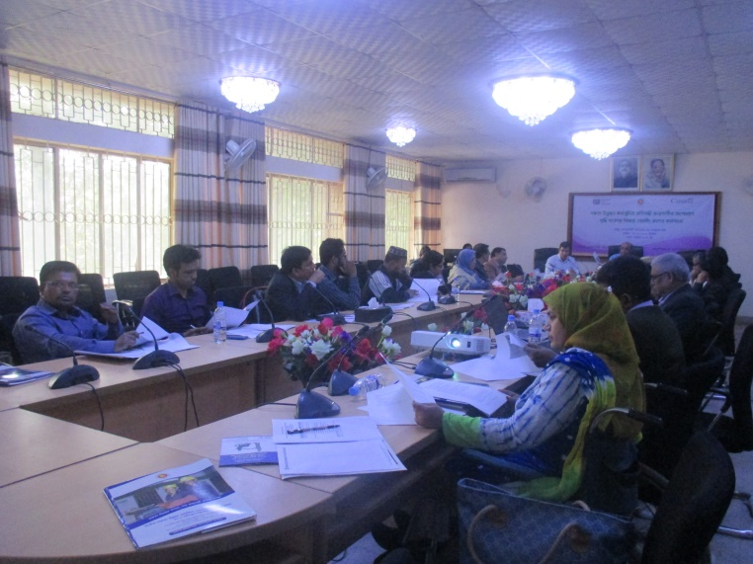**F) The 6th workshop** on Mainstreaming National strategies for Inclusion of PWDs in Skills Development was being organized by National Skill Development Centre (NSDC) Secretariat in collaboration with International Labour (ILO)-Bangladesh on 19th November, 2015 at NSDC Secretariat. WDDF Chairperson Shirin Akhter and Project Officer TahseenShowkat were participated in this workshop. A brief presentation on the disability inclusive strategies was being present and group discussion on this presentation is being organized for analysis the gaps and the reasons for those gaps. Chairperson ShirinAkhter and Project Officer TahseenShowkat of WDDF have joined in a group of 5members, including Department of Social Service (DSS) officers. They discussed about the increasing participation of PWDs in all skills development programs especially WWDs. Chairperson ShirinAkhter said that at least 40% of WWDs enrollment should be ensured and inclusion process of PWDs in training institution should be monitored and resolve the problems through considering special needs of WWDs for inclusion in skills development programs.

**3. Symposium/Training/ Round table Conference/ Dialogue/Seminar/Roundtable discussion:**

**A)** A Symposium on Gender Sensitive Training/Frontier was being organized by CCA & DRRA on 21st April, 2015, at Ascote Palace, Baridhara, Dhaka. A Research Report on the situation of women in disaster and how do the women survive in different types of disasters e.g. Ila,Sidr,flood was being presented in this symposium but the issue of WWDs is not being included in this research report. So we raised our voice to include the issue of WWDs & the representatives of civil society are agreed with us on this issue.

**B) A** Round Table Conference on Disabled Friendly Budget2015-16 was being organized by Access Bangladesh Foundation, on 7th May, 2015, at Prothom- Alo Office, C.A.Bhaban, Kawran Bazar, Dhaka. Ashrafun Nahar, Executive Director of WDDF was the speaker in this conference on behalf of women with disabilities. She strongly raised her voice in order to allocate budget in all ministries considering the development issues of persons with disabilities. She explained that it is not possible to consider all types of development of persons with disabilities by the ministry of Social Welfare and emphasized on the budget allocation for persons with disabilities in the areas of communication & education. She also mentioned in her speech that as persons with disabilities are an integral part of the nation so without planning & allocating disability inclusive national budget it would not be possible to bring expected development for the nation.

**C)** A very Professional Training **on Project Proposal Writing** was being organized by Bangladesh Visually Impaired Peoples Society (BVIPS) from 29th to 30th May, 2015, at the Conference room of National Forum of Organizations Working With the Disabled (NFOWD). Shirin Akhter, Chairperson and Ashrafun Nahar, Executive Director of WDDF were participated in this training.

**D)** A Dialogue on Investment in Education for Ending Child Marriage with Policy Makers and Civil Society was being organized by World Vision Bangladesh on 13th June, 2015 at Brac INN Centre, 75 Mohakhali, Dhaka. We raised our voice strongly to include the issue of girl’s with disabilities in this dialogue.

E) An interactive Dialogue with Policy Planners and DPOs Representatives was being organized by SEID Trust on 25th June, 2015 at LGED Bhaban. The inclusion of Persons with Intellectual Disabilities in main streaming process and their participation in policy making and planning level are discussed elaborately in this dialogue. All the participants including Ashrafun Nahar, Executive Director of WDDF has agreed that the Persons with Intellectual Disabilities are left behind of progress. They should be included in the main stream of policy making and planning. The Executive Director of WDDF strongly suggested the Minister of Social Welfare that the Person with Intellectual Disabilities should be included in all the programs of all ministry as well as He included the women with disabilities in Women & Children Affairs Ministry.

**F) A** seminar on Problems and Solutions of Persons with Disabilities was being organized on 26th January, 2015 at Gulshan-2, Dhaka. The entire participants are divided into two groups.

One group presents the major problems of PWDs and another group presents the solutions of problems.

**G) A** seminar about Employment of women was being organized on 28th February, 2015,at Dhaka Reporters Unity.

**H)** A Seminar on Development of Autistic and Persons with Disabilities as well as to enhance the abilities of NGOs was being organized by NGO Affairs Bureau on 22nd June, 2015 at BiamFoundation ,Escaton road, Dhaka Executive Director and a General member of WDDF were participated in this seminar. The current activities of NGOs are discussed besides, the strategies and future plan on how enhancing the capabilities of NGOs for improving the situation of Autistic & Persons with Disabilities (PWDs) are being discussed elaborately in this seminar.

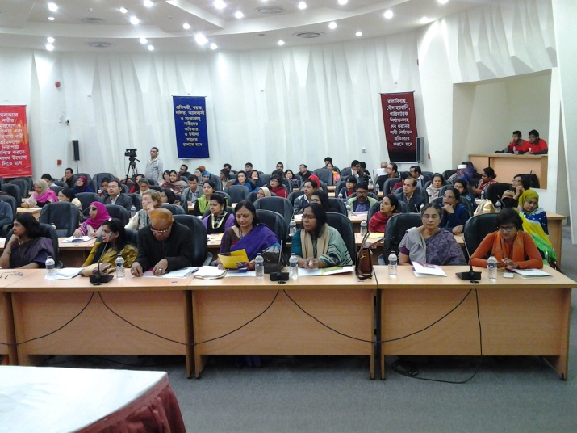**I) A N**ational Seminar on Making Disable Friendly Rules in working areas and Create employment opportunity for women with disabilities was being organized by National Council of Disabled Women (NCDW) on 2nd August, 2015 at Dhaka Reporter’s Unity. The participants were discussed about Positive Attitude of Labor Ministry, Accessibility, disable friendly IT system, accessible transport and security at workplace which is important to continue WWDs job.

**J)** A National Seminar on Women’s Political Empowerment, Gender Responsive Governance and Services was being Organized by Member Alliance Organizations of Steps Towards Development in collaboration with Democracy Watch, Khan Foundation and Prip Trust on 4th November, 2015 at CIRDAP Auditorium,Dhaka. Chairperson Shirin Akhter and Project Officer TahseenShowkat, WDDF were participated in this seminar. A study report on Aporajita Women political Empowerment was being present in this seminar. A number of Honorable Members of Parliament and Local Government, selected representatives shared their experience. Chairperson Shirin Akhter also raised her voice about the political involvement and participation of women with disabilities. She also said that if women with disabilities are being empowered politically, they would play a vital role in development.

K) A roundtable discussion on Accessible Election Procedure for PWDs was being organized on 2nd December, 2015 at CIRDAP Auditorium. Accounts Coordinator Md. Hasanuzzaman was present in this roundtable discussion. PWDs faced many barriers in election procedure E.G. inaccessibility, infrastructure, voting materials, negative attitude of responsible officers of election procedure, polling agent and lack of information. Md. Hasanuzzaman said that online vote can be effective for PWDs.

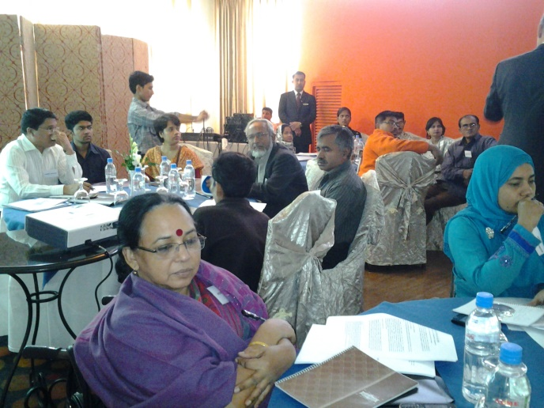4. **Consultation Meeting:**

WDDF participated in Seven Consultation Meetings in this reporting period.

A) The 1st Meeting on Gender Sensitive Budget 2015-16 was being organize on 4th May, 2015 at National Press Club. In this meeting we raising our strong voice on behalf of WDDF to prioritize disability issue highly in allocation of gender sensitive budget2015-16. Budget should be allocated for every ministry to ensure the participation of persons with disabilities in the ongoing programs of all ministries in order to include persons with disabilities in the main stream level. All ministries should adopt special project including budget allocation on behalf of each ministry in order to activate & actualized Persons with Disabilities Rights and Protection Act2013.

B) The 2nd Discussion Meeting on Reaction after Budget was being organized by Access Bangladesh Foundation and Bangladesh DRF Co-Ordination Committee on 6th June’2015, at Dhaka Reporter’s Unity. The Executive Director of WDDF participated in this discussion meeting and raised her voice mentioning different important areas where no budgetary allocation for Persons with Disabilities (PWDs).

C) **The 3rd Preparation meeting for Consultation Meeting with World Bank,** Before the consultation meeting with World bank on Safeguard Disability issue, was being organized by Access Bangladesh Foundation on 9th November, 2015, at Citygarden,Shishumela,Dhaka. Executive Director AshrafunNaharMisti and Projecct Officer TahseenShowkat of WDDF, Albert Mollah Executive Director, Access Bangladesh Foundation, Advocate Rezaul Karim Siddique,BLAST, Shamima Aziz, Project Coordinator,NCDW, LisiDesai, Program Director, Turning Point Foundation were being present in this preparation meeting. They discussed about the inclusion of disability issue in Worldbank Safeguard policy.

**D) The 4th Consultation Meeting with World Bank** Bangladesh was being organized on 10th November, 2015 at Bongobondhu International Conference Centre. A presentation on setting standard for sustainable development was being present. WDDF Executive Director Ashrafun Nahar Misti and Project Officer TahseenShowkat were participated in this meeting. Executive Director AshrafunNaharMisti said about the accessibility of PWDs. She said that accessibility definition is not incorporated in the policy. Accessibility definition should be included in the policy in light of UNCRPD. Bangladesh has PWDs Rights and Protection Act and the National Building Code. Both Acts emphasize on accessibility, without accessibility PWDs especially WWDs won’t be positively participated in mainstreaming activities and they could not be benefited from World Bank project. She also said that disability issue should be included in main text not in footnote.

**E) The 5th National Consultation** on Sustainable Development Goals & Disability in Bangladesh Perspective was being organized by Action Aid Bangladesh in collaboration with Centre for Services and Information Dissemination (CSID), on 18th November, 2015, at BIISS Auditorium,Dhaka. WDDF Executive Director Ashrafun Nahar Misti and General Member Afroza Akhter Nipa present there. Ashrafun Nahar Misti, Executive Director, WDDF mentioned that, disability issue is included in the following goals of SDG-these are no-4,8,10,11& 17. All goals are universal. She also said that through the inclusion of disability issue in SDGs, Bangladesh will hopefully bring an improvement in the quality of lives of PWDs especially WWDs. Monitoring committee should be activated and allocate budget for PWDs.

F) The 6th consultation meeting on Developing Multi- Sectoral Responses to Domestic Violence was being organized by Bangladesh Legal Services and Trust (BLAST) in it’s own office, on 14th December, 2015. Accounts Coordinator Md. Hasanuzzaman was present there. The Domestic Violence (Protection and Prevention) Act2010 (DVPPA) is a landmark piece of legislation which recognizes domestic violence as a national issue in Bangladesh and provides specific remedies against abuse in a domestic relationship . In view of the DVPPA some gaps have been identified, these gaps are fulfilled by some recommendation. E.G. family members, support for men, support for children, interviewing survivors, multi agency work, awareness raising and advocacy, empowerment programs.

G) The 7th c**onsultation meeting for building Policy Forum** on Access to health and Education for All Children and Youth with Disabilities (AHEAD) in Bangladesh was being organized on 17th December, 2015, BRAC INN,Mohakhali,Dhaka. A brief discussion on inclusive education: policy & practice is being discussed here, WDDF representative also included the health & education issue of WWDs.

**5. CEDAW Platform Meetings:**

**WDDF participated in Five CEDAW Platform Meetings in this reporting period**

**A) The 1st** Meeting of Citizens Initiative on CEDAW Bangladesh (CICBD) on CEDAW Reporting was being organized by Steps towards Development (STD) in it’s office, on 8th January, 2016. WDDF Executive Director was present there and thankful to the organizer for ensuring accessibility of different types of participants with disabilities in the National Press conference which was being held on 22nd December, 2014. The entire participants of this meeting gave a short evaluation on National Press conference and approved the meeting minutes.

**B)The 2nd** Meeting of Citizens Initiative on CEDAW Bangladesh (CICBD) on CEDAW Reporting was being organized by Steps Towards Development (STD) in it’s office, on 30th April,2015. Ranjankarmoker, Executive Director of STD presided over the meeting.

**C) The 3rd** Meeting of Citizens Initiative on CEDAW Bangladesh (CICBD) on CEDAW Reporting was being organized by Steps Towards Development (STD) in it’s office, on 24th June, 2015.

**1.** To actualize the recommendations of CEDAW committee for Bangladesh,a number of programs are being discussed and detailed plan of organizing these programs is being adopted.

**2.** The process of finalizing and submission of CEDAW alternative & shadow report is being discussed elaborately in this meeting.

**D) The 4th** Meeting of Citizens Initiative on CEDAW Bangladesh (CICBD) on CEDAW Reporting was being organized by Steps Towards Development (STD) in it’s office, on 16th August, 2015. Discussions of this meeting were to share the information of CEDAW report and how the WWDs issue is being incorporated in this report. This was also the preparation meeting of the press conference on ratification & implementation of CEDAW at 2nd September, 2015. Chairperson Shirin Akhter and Accounts Coordinator Md. Hasanuzzaman of WDDF were present in this meeting.

E) The 5th Meeting of Citizens Initiative on CEDAW Bangladesh (CICBD) on CEDAW Reporting was being organized by Steps towards Development (STD) in it’s office, on 18th November, 2015. This meeting was presided over Mrs. Ferdowsi Rita, coordinator of BARCIK. Executive Director, Ranjan Karmaker of Steps Towards Development has discussed the proceedings of previous meeting. They gave their consent with unanimous approval. Finalization of CEDAW National Sharing Program is the main agenda of this meeting. CIC-BD platform discussed about the chief guest, tentative number of participants, date, venue and budget. Divisional sharing meeting on CEDAW report will be held during November and December 2015. WDDF will join with the organizing team of Chittagong.

**6. NGO Coordination Meeting with DC:**

**WDDF participated in Five Monthly NGO Coordination Meeting in this reporting period.**

**A)** The 1st monthly NGO Coordination Meeting was being organized by District Commissioner in DC office, on 10th August, 2015. A number of issues e.g. Last meeting resolution, presentation of three NGOs,Question and Answer about presentation were being discussed in this meeting. Shirin Akhter, Chairperson, described about WDDF as WDDF participated in this meeting for the first time.

**B)** The 2nd monthly NGO Coordination Meeting was being organized by District Commissioner in DC office, on 7th September, 2015. Md.Hasannuzzaman, Accounts Coordinator of WDDF was present in this meeting.

C) The 3rd monthly NGO Coordination Meeting was being organized by District Commissioner in DC office, on 13th October, 2015. Shirin Akhter, Chairperson and Project Officer Tahseen Showkat, were present in this meeting.

D) The 4th monthly NGO Coordination Meeting was being organized by District Commissioner in DC office, on 17th November, 2015. Shirin Akhter, Chairperson and Project Officer Tahseen Showkat, were present in this meeting.

E) The 5th monthly NGO Coordination Meeting was being organized by District Commissioner in DC office, on 14th December, 2015. Shirin Akhter, Chairperson and Project Officer Tahseen Showkat, were present in this meeting.

**7. Press Conference:**

**A) A** press conference on Ensure Full Ratification and Implementation of CEDAW was being organized by Citizens Initiative on CEDAW Bangladesh (CICBD) on 2nd September 2015, at National Press Club. ShierinAkhter, Chairperson, WDDF was present there and spoke about to create demand for withdraw the reservation and full implementation of CEDAW articles. As WDDF always raises voice about the rights of Women with Disabilities, so, she also said that without implementation of CEDAW the rights of women especially WWDs rights will be violated.

**B)** A Press Conference on Reduce of Injustice was being organized by Human Rights Forum of Bangladesh (HRFB) on 20th May, 2015 at Dhaka Reporters Unity. The issue of reducing Injustice against persons through creating accessibility of PWDs in justice is being elaborately discussed in this press conference.

9. Discussion meeting of Citizens Initiatives on Domestic Violence (CIDV):

A) A meeting on Citizens Initiative on Domestic Violence (CIDV) was being organized by Amra O Pari in it’s office, on 28th January, 2015. WDDF representative was present there. In this meeting CIDV members discussed about organizing an alliance of Women which will take initiatives to reduce violence against women.

B) A meeting on Citizens Initiative on Domestic Violence (CIDV) was being organized by Care Bangladesh in it’s office, on 4th November, 2015. This meeting was about the TOR on DVPPA. A decision has taken for some changes in TOR. Chairmen ShirinAkhterof Women with Disabilities Development Foundation said that the term Women with Disabilities must be included in this TOR. She also raised her voice about the family rights violence against Women with disabilities.

**10.** WDDF as a Resource Organization:

Ashrafun Nahar, Executive Director, WDDF worked as resource person in a 5days long Training on Disability Inclusive Programming was being organized by World Vision From 1st August to 6th August, 2015 at PROSHIKA HRDC, Koitta, Manikgonj . Executive Director, Ashrafun Nahar Misti of WDDF and Three facilitators are facilitated the training. The purpose of this training is to develop a resource pool on disability inclusive programming from the field offices of WV BGD by equipping them with expected attitude, knowledge and skills.

**11. Day Observance:**

A) International Women Day was being organized by Ministry of Women and Children Affairs (MOCA) on 8th March, 2015 at Bongobandhu International Conference Centre. Honorable Prime Minister ShiekhHasina of Bangladesh was the chief guest of this program. She said that without the empowerment women in every sector development could not be possible, so women should be included in mainstream development. Discussion meeting and cultural program was being held on that day. Ashrafun Nahar, Executive Director, Shirin Akhter, Chairperson, Tahseen Showkat, Project Officer and Md. Hasanuzzaman were participated in this meeting.

B) 24th International Day of Persons with Disabilities and 17th National Day of Persons with Disabilities was being organized by Social Welfare Ministry of Bangladesh in collaboration with DPOs and NGOs on 3rd December, 2015 at Bongobandhu International Conference Centre. Honorable Prime Minister ShiekhHasina of Bangladesh was the chief guest of this program.

Ashrafun Nahar, Executive Director, Shirin Akhter, Chairperson, Tahseen Showkat, Project Officer and Md. Hasanuzzaman were participated in this meeting.

**12. National Conference:**

A) A national Conference on DPO movement in Bangladesh: Prospects & Challenges was being organized by Access Bangladesh Foundation in collaboration with Bangladesh Protibandhi Unnayan Sangstha (BPUS), Federation of DPOs Sitakund and Disability Rights Fund (DRF) on 25th November, 2015, at BIAM Foundation,Dhaka. WDDF Executive Director Ashrafun Nahar Misti and Project Officer Tahseen Showkat were participated in this conference. WDDF Executive Director Ashrafun Nahar Misti said that increase the number of women with Disabilities organizations and empowered those organizations with the funding of National Foundation of Persons with Disabilities. She also facilitated one of the session’s Good practices of DPO’s advocacy in education & employment for persons with disabilities.

**B) Dhaka Conference on Disability and DRM:**

Dhaka Conference on Disability & Disaster Risk Management (DRM) was being organized jointly by Ministry of Disaster & Relief,Ministry of Social Welfare, Ministry of Women & Children Affairs,Centre for Disability in Development(CDD),in collaboration with UNISDR. Co organizers were National Forum of Organizations Working with the Disabled (NFOWD), LGD,DDM,DSS,JPUF,NDDPT,IDMVS& BDPC from 12th to 14th December, 2015 at Krishibid Institute of Bangladesh (KIB) Complex,Farmgate, Dhaka. Shirin Akhter, Chairperson and Project Officer Tahseen Showkat were participated in this conference. Mr. Mofazzal Hossain Maya, Bir bikrom,MP,Honorable Minister, Ministry of Disaster Management& Relief has delivered inaugural speech. MeherAfrozChumki,State Minister, Ministry of Women & Children Affairs and Tariq-Ul-Islam, Secretary, Ministry of Social Welfare were delivered their speech. SaimaHossain, Member, WHO’s Expert Advisory Panel on Mental Health & Chairperson National Advisory Committee on Autism, Bangladesh, was present the keynote paper on Disability in Bangladesh, the purpose program.

The conference was being arranged with Inauguration ceremony, 4 plenary session,9 concurrent session,5 Special event, banquet & conference closing event.

First day of Conference divided into three parts -  
1. Inauguration with launching of the book Crises, Conflict and Disability   
2. Plenary Session on Understanding DRM Context & Bangladesh, the Journey: ensuring disability inclusion in Sendai Framework for disaster risk reduction, roles of PWDs and their organizations  
3. Concurrent session-there is three concurrent sessions and WDDF participated in concurrent session 3 on Women, Children & Youth with Disabilities in DRM. Three papers were being present in this session, this are- a. increased risk factors for WWDs, b. Inclusion of PWDs in DRR, c. Inclusiveness should not be only in policies it should be practice.  
WDDF Chairman Shirin Akhter said that during disaster WWDs facing many problems &abuse, how we generate data or information during this time about WWDs. MsNasima Begum ndc, Secretary, Ministry of Women & Children Affairs chaired this session.

In 2nd day of conference WDDF representatives participated in two concurrent sessions. Concurrent session 6 on importance of research, studies, technology and accessible information management system in DRM. There are 5 papers are being present. Prof Khondoker MokaddemHossain, Pro-Vice Chancellor, Open University chaired this session. Another concurrent session is session9, where 3paper presenters & Dr. Rownak Hafiz, chaired this session.

In 3rd day conference closed with the formal adoption of Dhaka Declaration & media briefing on the outcome of the conference and way forward.

**Upcoming impact of this Reporting Year**

**1. It is a great achievement for us that WDDF has got registration from NGO Affairs Bureau in 2015 and in this consequence, WDDF has achieved the capability to receive foreign donation independently.**

**2. The women leaders of WDDF have to face threats in order to destroy the leadership of WWDs but the women leaders of WDDF have overcome the challenges with their strong leadership and they are running WDDF as an independent along with WWDs right based organization successively for establishing an inclusive and anti discriminatory society for WWDs through their proper empowerment.**

**3. 22 girls students with disabilities of different education institutions (From primary to higher education) are continuing their education as well as 15 women with disabilities are starting Income Generating Activities (IGA) through education along with the IGA support of WDDF.**

**4. Leadership capacity has been developed among almost Fifty WWDs and simultaneously they become aware about their basic along with human rights as other citizens as well as Thirty WWDs become about their reproductive health rights for the first time and simultaneously they’ve got opportunity to learn how to take care of their own reproductive health.**

**5. Victim WWDs are getting support from One Stop Crisis Centre (OCC) and victim support centre through the strong advocacy and regular follow up of WDDF.**

**6. WDDF is working as a resource organization to formulate national legislation, policy, plan, programs and international documents as well as the executive Director of WDDF facilitates different training/programsas resource persons nationally along with internationally in order to include disability issue properly.**